**Outside Bar Trading Strategy**

The goal is to 100% automate this strategy so it can trade without monitoring across multiple markets.

This trading strategy follows a simple price action pattern set up with clear criteria for entry and exit. The price action pattern is based on an Outside Bar (OB) immediately followed by an Inside Bar. The Inside Bar is defined as a bar that its high is less than or equal to the high of the previous bar and the low is greater than or equal to the low of the previous bar. Once an inside bar is printed, that is the set up. To trigger an order for entry, a following bar must close above the high of the Outside bar (for a long) or below the Outside Bar (for a short) to trigger a limit order to be placed. If a following bar closes above (or below) the Outside Bar a Long Limit Order is places at the 50% level of the Outside Bar. This limit order remains in force until it is filled, or a new OB qualifies. See the section below for the criteria for a new OB qualification.

All yellow bars are considered “Inside Bars”. The bar immediately preceding the yellow bar is an “Outside Bar”. Note: The below chart has a indicator that highlights Inside Bars as yellow.

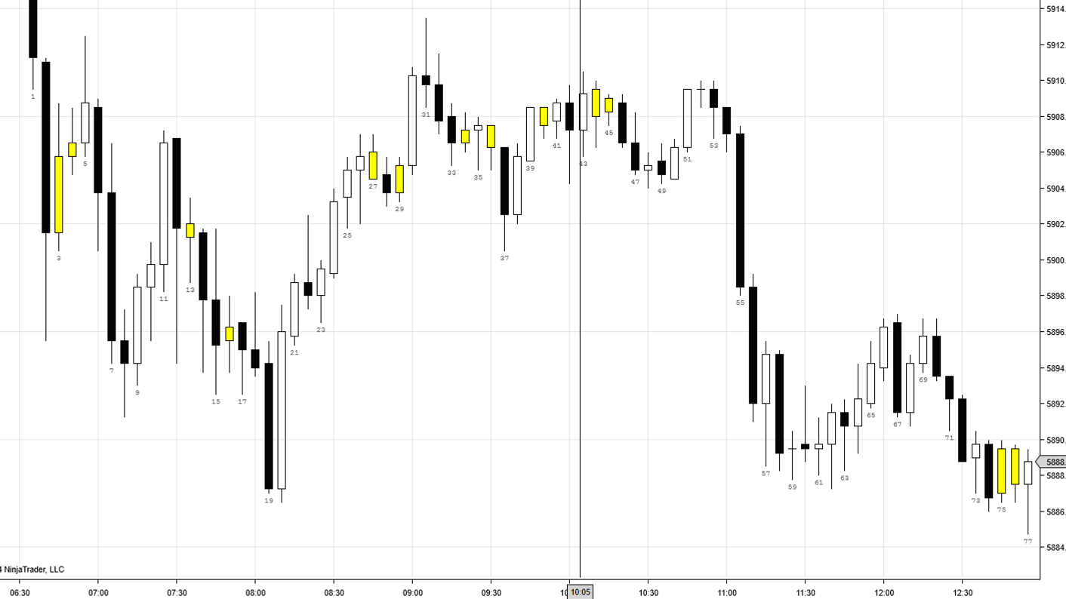

**Trade Management**

The limit order will have a predefined Profit Targets and Stop Losses associated with it. Those predefined Profit Targets and Stop Losses will be adjusted while in the trade if certain criteria are met. Those Profit Targets and Stop Losses will be configured accordingly. There are criteria to move the trade to break even if the trade is in profit and if it is in loss. If the trade is reaches the Profit BE level that is configured, the Stop Loss should be moved to BE plus or minus the configured ticks. If the trade reaches the Loss Break Even Level, the Profit Target should be moved to BE plus or minus the configured ticks.

Important – Similar to how ATM strategies work in Ninjatrader where Profit Targets and Stop Losses are cancelled as they are tied to each other, that needs to occur here as well.

Special Note on Trade Entry if currently in existing position trying to exit at BE. This can occur when an open trade hits the Loss BE point and the Profit Target is moved to BE +1 tick. Then a trade qualifies in the opposite direction. The new trade limit order entry point must be equal to the existing trade exit point. This will avoid the new trades limit order closing the existing position without entering a new position.

**Criteria for a new OB qualification**

If one is not currently in an existing trade and the existing OB has achieved the configured level to look for new OBs, and a new qualifying OB forms, then follow the most recent OB.

If a trade is a winner on an OB (ie. Achieves a profit target without adjusting it to bE), no more trades on that OB and look for next OB to follow.

**Configurable Conditions**

Typical configurations are indicated for trading ES.

**Number of Contracts** - Total number of contracts to buy / sell

**Minimum Size of the Outside Bar** - Maximum size is typically 9.5pts.

**Maximum Size of the Outside Bar** – Minimum size is typically 4 pts

**Entry Level where to apply the limit order** – It should be 1-100%. Typically, 50% level of the Outside Bar.

* Must be relative to a long or short position. For a long, 100% would be the top of the OB and for a short, the 100% would be the bottom of the OB

**Rounding for Entry**– In favor or against. if math for entry / exit does not work out to exact tick. Typically round to in favor of direction. Ie, if 50% level is 5999.875, I round entry down to 5999.75 for a long or up to 6000.00 for a short,

**Profit Levels Targets Up to 3** – Function (%) of the size of the OB. Typically, 150%*OB size. In other words, if the OB is 6 points, the profit target is 9 points from the entry if using 150%. Typically Trade 1 and 2 levels depending on account and market conditions. Also need to designate number of contracts per Profit Level Target.

**Profit Break Even Levels** – Option for points or function of the size of the OB. Typically, if the trade moves to 100%*OB in profit, I move the trade to BE +1 tick. Sometimes I do 5 points.

**Loss Break Even Levels** – Option for points or function of the size of the OB. Typically, if the trade moves against me 50%*OB, I move the trade to BE +1 tick.

**Stop Loss Level –** Catastrophic stop level, if trade does not exit at BE after Loss BE Level Hit. Typically, 150%*OB Size

**Break Even Ticks** - +/- ticks relative to L or S trade. Typically, BE level is +1 tick to cover commissions

**Level for new OB qualification** – Function of the OB. Where if price reaches the x% level of OB and new qualifying OB forms, I follow the new qualifying OB. NOTE, if prices reaches the x% level and new OB does not form, I follow the existing OB. Typically, I do 200%*OB

**Start Time / End Time** – Time strategy will run. This means it is looking for OBs and will enter new trades during this time. Typically, RTH trading hours (ie. 630am-12:50pm PST). If strategy turns on at 630am, it starts looking for OB from the opening candle to the End Time

**Action at End Time –** Option to close open position or stop taking new trades and let position run

**Auto Close Positions time** – Close all open positions and turn off strategy at this time. Typically, I will close all positions at 130pm PST and not take any new positions after 12:30pm PST.

**Max Daily Loss** – If the Max Daily loss is hit, there should be two options. 1. Close all open position immediately. 2. Let existing trade play out and if loss, no more trades for the day.